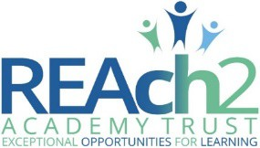
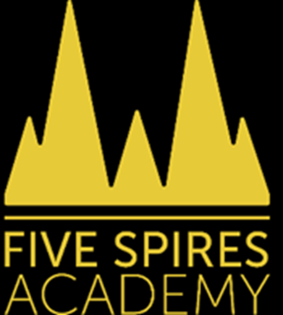
Five Spires Academy Equality Objectives 2026-2027
Date objectives approved by the Headteacher and the Local Governing Body: November 2026

Equality objectives – specific, measurable | Rationale | Success Measures | Progress over time
Objective 1: Improve outcomes for vulnerable groups  To reduce attainment gaps between disadvantaged pupils, pupils with SEND and their peers through high-quality teaching, adaptive practice and targeted support. | Internal and national assessment information show that some vulnerable groups achieve less well than their peers, particularly within the Early Years Foundation Stage and in some areas of literacy.* | The attainment gap between disadvantaged pupils and their peers will reduce over time.  SEND pupils will demonstrate improved progress and attainment from their individual starting points.  School assessment information will demonstrate improved outcomes in reading, writing and mathematics across vulnerable groups. | Progress Review 2025–2026 *  Vulnerable groups were monitored through termly pupil progress meetings, adaptive teaching and targeted interventions.  EYFS outcomes were strong overall, with 82% achieving a Good Level of Development. Outcomes for disadvantaged pupils were 50% (2/4 pupils) and SEND pupils 33% (1/3 pupils). These cohorts are very small and percentages should therefore be interpreted with caution.  The Year 1 Phonics Screening Check was a significant strength, with 97% of pupils meeting the expected standard. Outcomes for vulnerable groups were positive, with 100% of pupil premium pupils (4/4) and 66% of SEND pupils (2/3) meeting the standard.  Key Stage 2 outcomes were strong, with 87% achieving the expected standard in reading, writing and mathematics combined. 100% of disadvantaged pupils (2/2) achieved the expected standard and 70% of SEND pupils achieved the combined measure.  Attendance remained strong, with overall attendance at 96% and persistent absence at 10.2%, both comparing favourably with national figures. Attendance for disadvantaged and SEND pupils remained a key focus throughout the year.  Overall, vulnerable pupils made positive progress from their starting points. While attainment gaps remain in some cohorts, leaders recognise that small group sizes can significantly affect percentage outcomes and therefore evaluate success through both attainment data and individual pupil progress.
Objective 2: Improve attendance and engagement for vulnerable pupils  To ensure that all pupils, particularly disadvantaged pupils and pupils with SEND, attend regularly and engage fully in school life so that they can achieve their best possible outcomes. | Strong attendance and engagement are essential for pupils' achievement, wellbeing and inclusion. Although overall attendance at Five Spires Academy remains above national averages, leaders are committed to reducing persistent absence and ensuring that disadvantaged pupils and pupils with SEND can fully access learning, enrichment opportunities and wider school experiences. | Whole-school attendance remains above national figures.  Persistent absence remains below national figures.  Attendance gaps between vulnerable groups and their peers are minimised.  Disadvantaged pupils and pupils with SEND regularly access the full curriculum, educational visits, clubs and enrichment opportunities.  Pupil voice demonstrates that all pupils feel included, valued and able to participate fully in school life. | Progress Review 2025–2026 *  Overall attendance remained strong at 96%, exceeding the most recent national figure of 94%.  Persistent absence was 10.2%, remaining significantly below the national figure of 17.3%.  Leaders maintained robust attendance monitoring, regular attendance meetings and effective partnership work with families and external agencies.  Attendance for disadvantaged pupils and pupils with SEND remained a priority throughout the year, helping to secure regular access to learning and wider school opportunities.  Vulnerable pupils continued to participate fully in school life, supporting positive outcomes, inclusion and wellbeing.
Objective 3 – To foster a culture of inclusion, respect and belonging by developing pupils' understanding of diversity, equality and protected characteristics through the curriculum and wider school life. | Five Spires Academy is committed to ensuring that all pupils feel valued, represented and included. Through a broad and inclusive curriculum, meaningful community engagement and the promotion of British Values, pupils develop the knowledge, understanding and attitudes needed to thrive in modern Britain. | Pupils demonstrate an age-appropriate understanding of equality, diversity and protected characteristics.  The curriculum reflects diverse voices, cultures, experiences and achievements.  Pupil Voice demonstrates that children feel safe, respected and included.  Opportunities to celebrate different cultures, faiths and communities are embedded throughout the school year.  Strong partnerships with families and the wider community support pupils' understanding of inclusion and belonging. | Progress Review 2025–2026  A broad and inclusive curriculum continued to promote diversity, equality and representation across subjects.  Assemblies, curriculum events and themed celebrations enhanced pupils' understanding of different cultures, faiths and communities.  Strong community links were maintained through partnerships with local organisations, charities and faith groups.  Parents and carers were actively engaged through regular school events and celebrations.  Pupil Voice and Parent Voice feedback indicated that pupils feel safe, valued and included within the academy community.  Curriculum monitoring confirmed that opportunities to promote diversity, inclusion and respect are embedded across the school.

*Leaders recognise that a number of vulnerable groups within the academy consist of very small cohorts and therefore evaluate both attainment outcomes and individual pupil progress when considering impact.

